Commercial BusinessOwner’s Package (BOP for short) is one of our most sold products. It is geared towards small to mid-size businesses. (Larger businesses would be directed towards a CPP policy instead.) The overall product name is “BusinessAssure” and this has a registered trademark.
There are 2 kinds of BOP policies:
BusinessOwners (BP)
Contractors and Tradesmen (CT)
As you might guess, the “Contractors and Tradesmen” version is geared towards construction companies and other small businesses like plumbing, electricians, etc. BusinessOwners is intended more for Dentist offices, beauty salons, shoe stores, (or other small retailers), etc.
BOP shares some features (and even coverages) that Commercial Property uses. However, BOP does not have such a wide array of items to insure. It also has some Class Codes, very similar to GL. And it can include some Commercial IM endorsements as well. So BOP is sort of a mini-CPP policy.
Another feature that BOP shares with Commercial Property is the concept of a “Blanket Group”. BOP only offers 3 kinds of blankets:
- Building and Personal Property Combined
- Building only
- Personal Property only
BOP does not have Special Classes. Business Income is offered as a coverage, but it’s much simpler than what is offered in Property. Neither Business Income nor Earthquake nor Flood can be included in a Blanket Group. These are just coverages on BOP. Here is an example from the BOP Dec mockup:
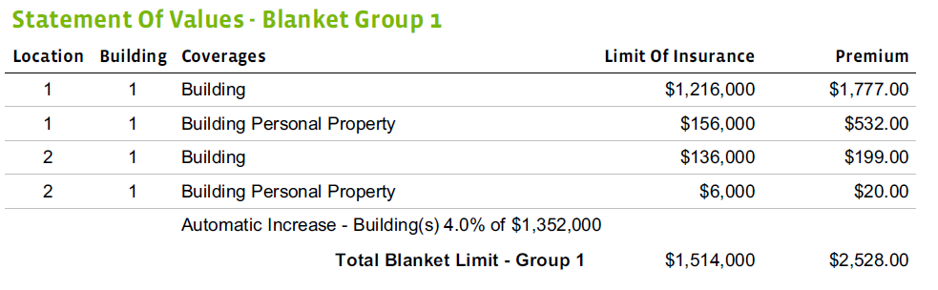
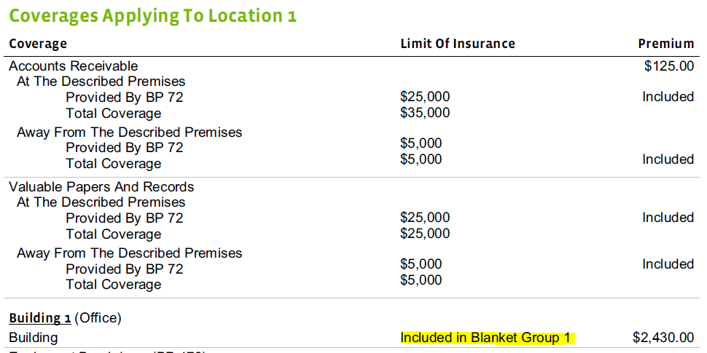
BOP does offer something unique: Choice Endorsements. These are similar to the “bundles” that are offered on PL Property for HM policies. It’s basically an easy way to offer additional coverages/limits for certain types of businesses that we commonly insure. They are also similar to the Optimum packages for other CL products.
Most BOP policies start with a BP 00 03 endorsement as their contract. This contract adds some coverages by default to the policy with basic limits. When a policy adds a choice endorsement, then that endorsement (BP 72 for example) provides additional coverage. When a choice endorsement is added to the policy, the customer can still choose to have an even higher limit than what is provided by the choice endorsement. (The additional limit usually has a premium charge with it.) In the legacy system, these limits are clearly called out on the dec pages and the preference was to keep this functionality in the new layout. This necessitated 2 indentations in OTE to accomplish this formatting because some of the choice coverages have cov terms:
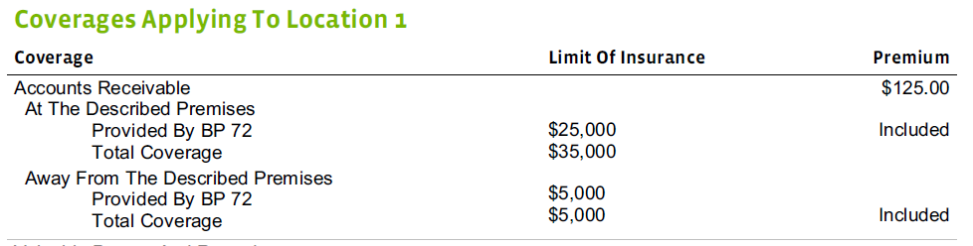
For some coverages that are in Choice, there are no cov terms, so they only need 1 level of indentation:
This variability in the indentations, while it was ultimately accomplished in OTE, was very challenging to get working all the time. Thus, BOP is the only product that has double indentation.
The Quote display for BOP differs significantly from the Dec pages, and especially when it comes to the Choice coverages and default coverages included on the policy.
The Choice coverages have their own section on the Quote, and it is not necessary for us to show any details about how much the limit is for just choice vs. if the customer decides to increase that limit.
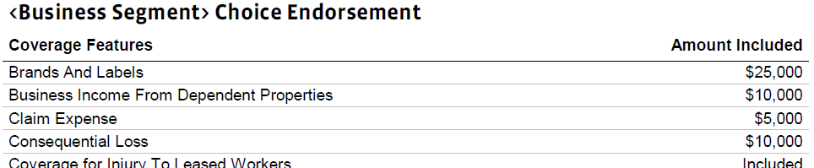
There is also a special section for “Included” coverages, which come with the BP 00 03 (if on the policy.)
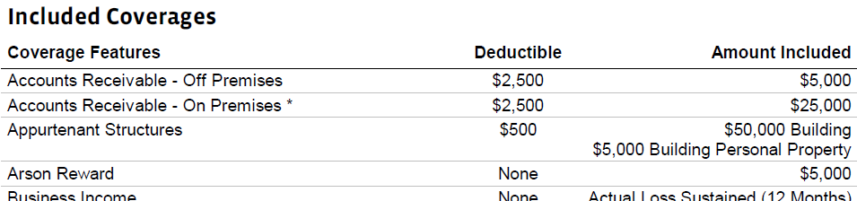
Also special for Contractors and Tradesmen policies is an option Contractors Equipment schedule that is similar to a PL inland marine rider on a homeowner’s policy.

